Early Years Foundation Stage (EYFS)
We follow the Early Years Foundation Stage Statutory Framework, which sets the statutory standards for the development, learning and care of children from birth to five years. You can find further information on the Foundation Years website. We use Development Matters to help plan, assess and observe children in order to support their development.
Reception Curriculum
Here at Mrs Ethelston’s Primary we have a thematic approach to the curriculum in Reception, meaning we develop children’s skills through half termly themes such as ‘Things that Grow’ and ‘Celebrations’ focusing on all 7 Areas of Learning. We tailor our curriculum around the children’s individual interests and needs. Our planning is based on the recognition that children learn best through play and active learning, through a balance of both child-initiated and guided activities. We aim to provide children with appropriate challenge to create happy, critical thinkers and independent young people. We also join in with the whole school Christian core values each term using age-appropriate activities.
The curriculum is organised into the following seven areas of learning:
- Communication and Language;
- Physical Development;
- Personal, Social and Emotional Development;
- Literacy;
- Mathematics;
- Understanding the World; and
- Expressive Arts and Design

Unique Child
At Mrs Ethelston’s Primary we understand that every child is a unique child who is constantly learning and can be resilient, capable, confident and self-assured. Each individual child’s needs are catered for by a highly qualified Early Years team who aim to provide an inclusive and nurturing atmosphere. We encourage all children to become independent and inquisitive learners, giving them the confidence to have a go, explore and do things for themselves.

Positive Relationships
Children learn to be strong and independent though strong relationships with the significant adults in their lives. Before your child starts in Reception, we will arrange a variety of transition sessions within the summer term. Having a small experienced team ensures that every child quickly gets to know their class teacher and teaching assistant(s) which helps them to feel comfortable in their surroundings and ready to learn.

Enabling Environments
We have a range of stimulating resources indoors and outside to support your child’s learning and development. Throughout the day we follow a clear routine to provide a wealth of exciting, educational activities to facilitate children’s learning, predominantly through play and active learning.
RWI Phonics
We teach phonics using the RWI scheme from the very beginning of Reception, following the additional RWI Guidance, ‘Making a Strong Start’. Please refer to the specific section for RWI on our school website, found under: Curriculum>Subjects>Phonics.
Tapestry - An Online Learning Journey
The Reception staff keep ongoing learning journeys of each child through Tapestry which are available for parents and carers to view online. As an Early Years Team across our Trust, we now categorise observations using hashtags, e.g. #GG or #CI to show whether an activity was guided or child initiated. We also use a hashtag for each area of learning, e.g. #maths, #literacy, #UW on so on. We also encourage parents and carers to add Tapestry observations of their child, as we understand what a significant part parents and carers play in their child’s early learning and development. When completing an observation, we ask that parents and carers include #homelearning within their observation. Clicking on a specific hashtag allows staff to view the progression of a child’s skills in a specific area of learning, over time.
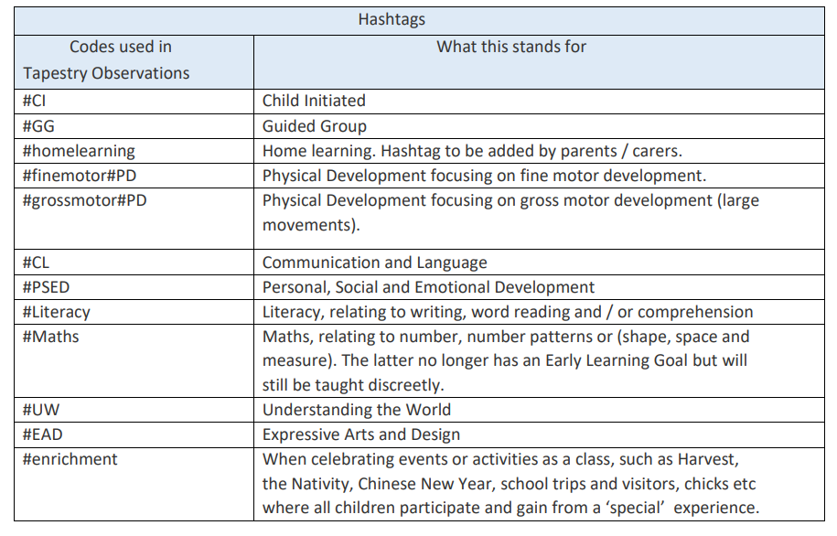
Reception Baseline Assessment (RBA)
Within the first six weeks of your child starting in Reception, they will complete a Reception Baseline Assessment, (RBA), one to one with their class teacher. 2021 Information for parents: reception baseline assessment The RBA is a short, interactive and practical assessment of a child’s early literacy, communication, language and mathematics skills when they begin school, using materials that most children of Reception age will be familiar with. It became statutory for all schools from September 2021. Its main purpose is to create a starting point to measure the progress schools make with their pupils between reception and year 6 / the end of key stage 2.
Early Years Foundation Stage Profile
At the end of the Reception year we carry out a statutory assessment of all children using the Early Years Foundation Stage Profile. The EYFS Profile is intended to provide a reliable, valid and accurate assessment of each child’s development in the summer term of reception. It is made up of an assessment of the child’s outcomes in relation to the 17 early learning goal (ELG) descriptors. Practitioners are expected to use their professional judgement to make these assessments, based on their knowledge and understanding of what the child knows, understands, and can do. The results of this assessment are reported to parents and carers in their child’s annual school report and to the Local Authority. For each ELG, teachers must judge whether a child is meeting the level of development expected at the end of the EYFS (expected) or not yet reaching this level (emerging).
Home learning
Home learning is introduced in Reception. This predominantly relates to practising phonics at home, using the sound cards that they will bring home as they are learnt, and to read and re-read their RWI books as regularly as they can. We also encourage you to share books with your child at home. In Reception, your child will choose a school library book to bring home every week. Reading to children is the best way of encouraging them to love books and reading. By reading stories aloud to children every day, you are forming a link for them between reading, comfort and love.
The Reception staff are always happy to talk to you about your child’s learning, so if you have any questions please ask.

